
Bachelor of Computer Applications

Semester – V

Business Analytics

Experiment No.: 3

Title: Building Dashboard

GitHub - https://github.com/DakshrajKurki/Assignment-Business-analytics

Submitted By: Dakshraj Singh Chandawat
Reg. No.: 2411021240050
Date: 04/09/2026

Submitted To:
Faculty Name: Mr. Aman Kumar Sharma

Department of Computer Application
Alliance University
Chandapura - Anekal Main Road, Anekal
Bengaluru – 562106

Experiment No.: 3
Building Dashboard
Problem Statement
You are a Data Analyst in a retail company. Sales data is stored in Excel files, customer data in CSV files, and product information in another source. Management wants a centralized reporting system. Import data from multiple sources into Power BI, establish the required connections, and prepare the data for business reporting.
Introduction
In today's business environment, organizations often store data across multiple platforms — spreadsheets, flat files, and relational databases — making it difficult to get a single, unified view of performance. Power BI addresses this challenge by allowing data from different sources to be imported, cleaned, modeled, and visualized within one platform. This experiment simulates a real-world retail scenario where sales, customer, and product data originate from different systems, and demonstrates the complete workflow of consolidating them into a single interactive business dashboard.
Methodology / Steps Followed
Step 1: Data Collection
The data required for this business analysis was collected from multiple sources to build a centralized reporting model, reflecting how a real retail organization typically stores its information across departments and systems.
- Sales data was obtained from the AdventureWorks Sales Data 2022 Excel file, containing transactional-level records such as order dates, quantities, and product/customer references.
- Customer information was obtained from the AdventureWorks Customer Lookup dataset, containing demographic details such as name, gender, marital status, and income.
- Product information was obtained from the AdventureWorks Product Lookup dataset, sourced from a MySQL database rather than a flat file.
- Product category information was obtained from the AdventureWorks Product Categories Lookup dataset.
- Product subcategory information was obtained from the AdventureWorks Product Subcategories Lookup dataset.
- Regional/territory information was obtained from the AdventureWorks Territory Lookup dataset.
Collecting data in this fragmented way reflects how sales, customer, and inventory systems in real businesses are rarely unified, and highlights why a consolidation tool like Power BI is necessary for effective reporting.
Step 2: Product Data Management Using MySQL
- Set up a MySQL database named "adventureworks" to manage the Product Lookup dataset independently of the other Excel-based sources.
- Verified the database and its tables using the queries USE adventureworks; and SHOW TABLES; in MySQL Workbench.
- Confirmed the Product Lookup table was available in the database, containing key fields such as ProductKey, ProductName, ProductSKU, ProductColor, ProductCost, ProductPrice, and ProductSize.
- Used this MySQL database as one of the data sources connected to the Power BI project.
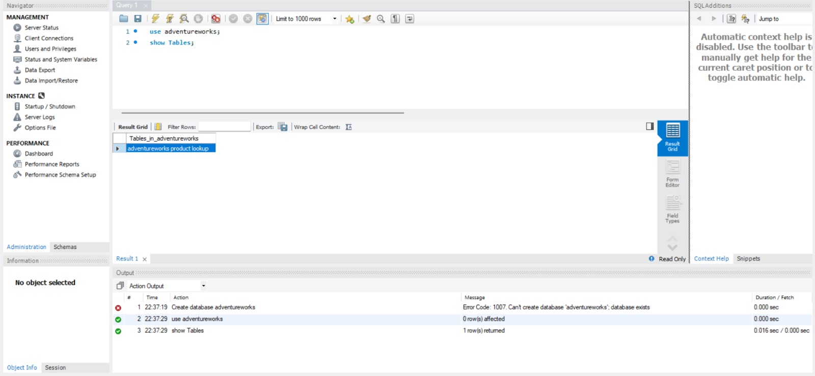
Fig 1: Verifying the Product Lookup table in MySQL Workbench
Step 3: Data Import into Power BI
- Opened Power BI Desktop and created a new project file.
- Imported the Sales Data 2022, Customer Lookup, Product Categories Lookup, Product Subcategories Lookup, and Territory Lookup datasets using the Get Data option.
- Connected Power BI to the MySQL database using the Navigator window to import the Product Lookup table.
- Loaded all six tables into the Power BI data model.
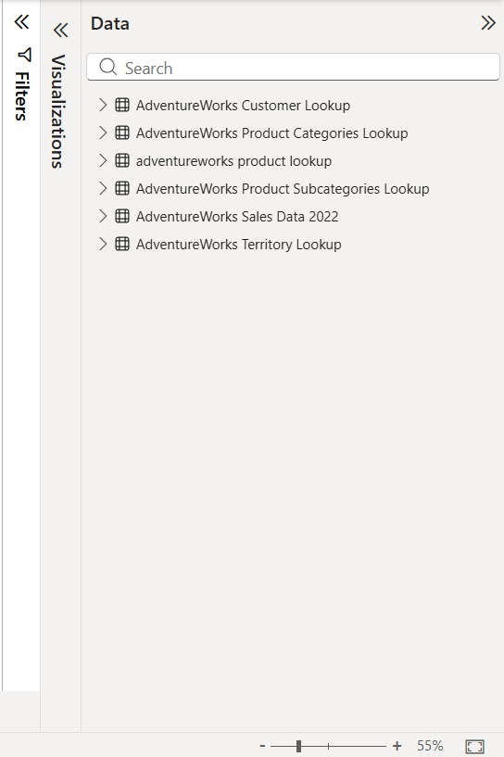
Fig 2: All six tables loaded into the Power BI Data pane
Step 4: Data Cleaning and Transformation
All transformation was carried out in Power Query Editor before loading the data into the model, ensuring the underlying data was consistent and analysis-ready.
- Promoted headers and changed column data types across all tables — converting date fields to Date type, key columns to Whole Number, and descriptive fields to Text type.
- Cleaned the Customer Lookup table by filtering out irrelevant rows and removing blank or bottom rows to ensure only valid, complete customer records remained.
- Verified column-level data quality using Power Query's column profiling, confirming 0% error and empty values across the cleaned columns.
- Removed unnecessary columns that were not required for reporting.
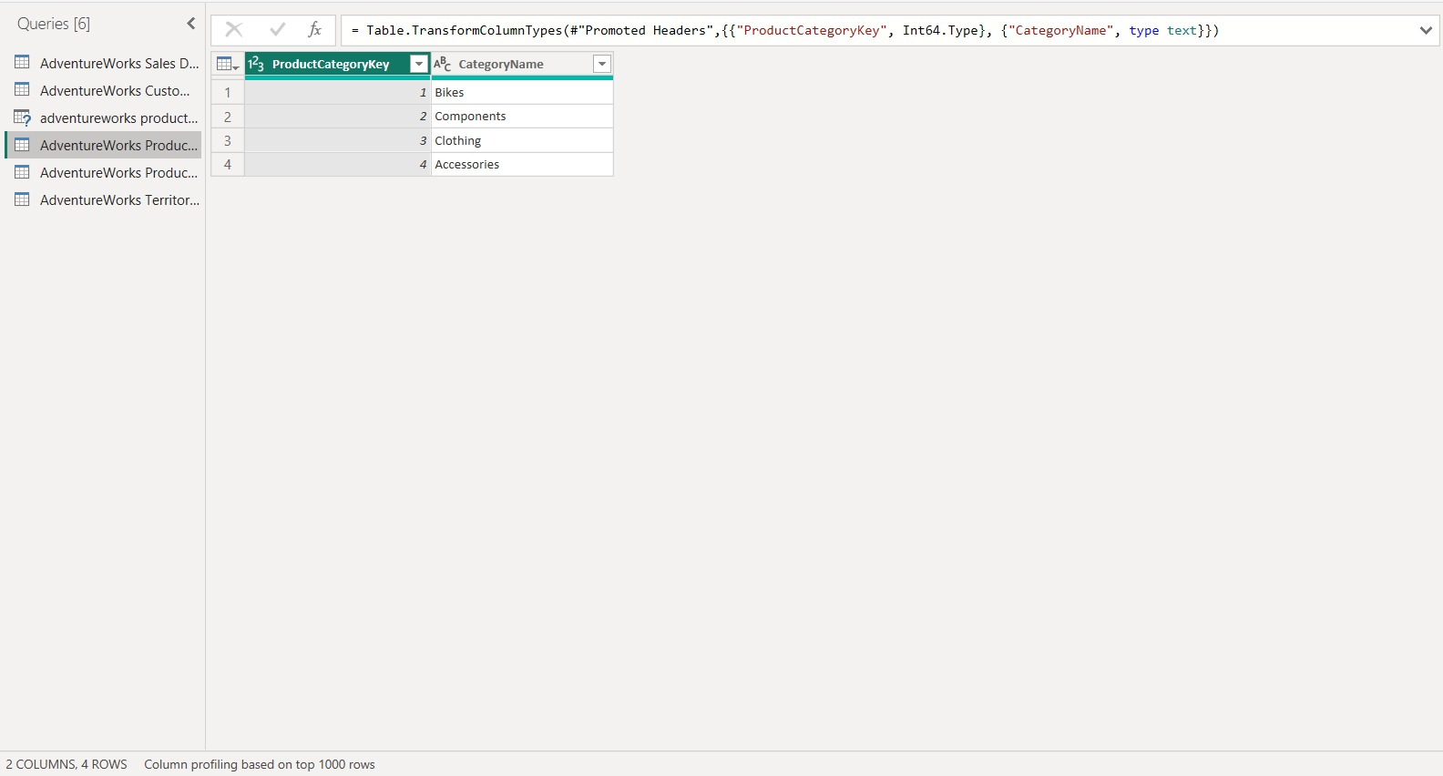
Fig 3: Cleaned Product Categories Lookup table
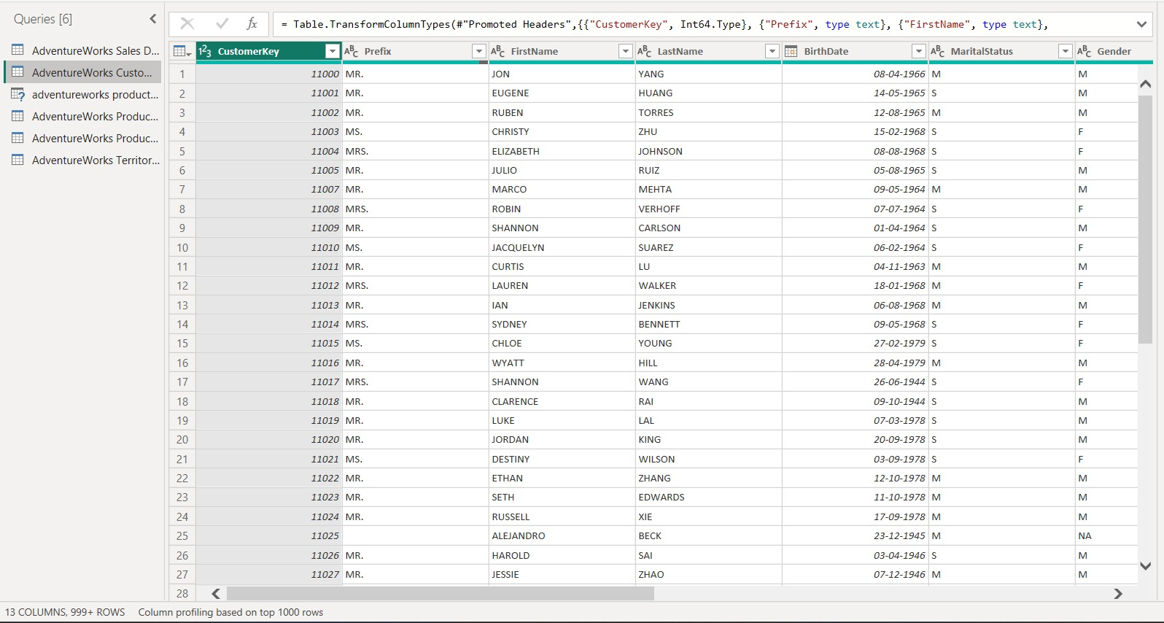
Fig 4: Cleaned Customer Lookup table
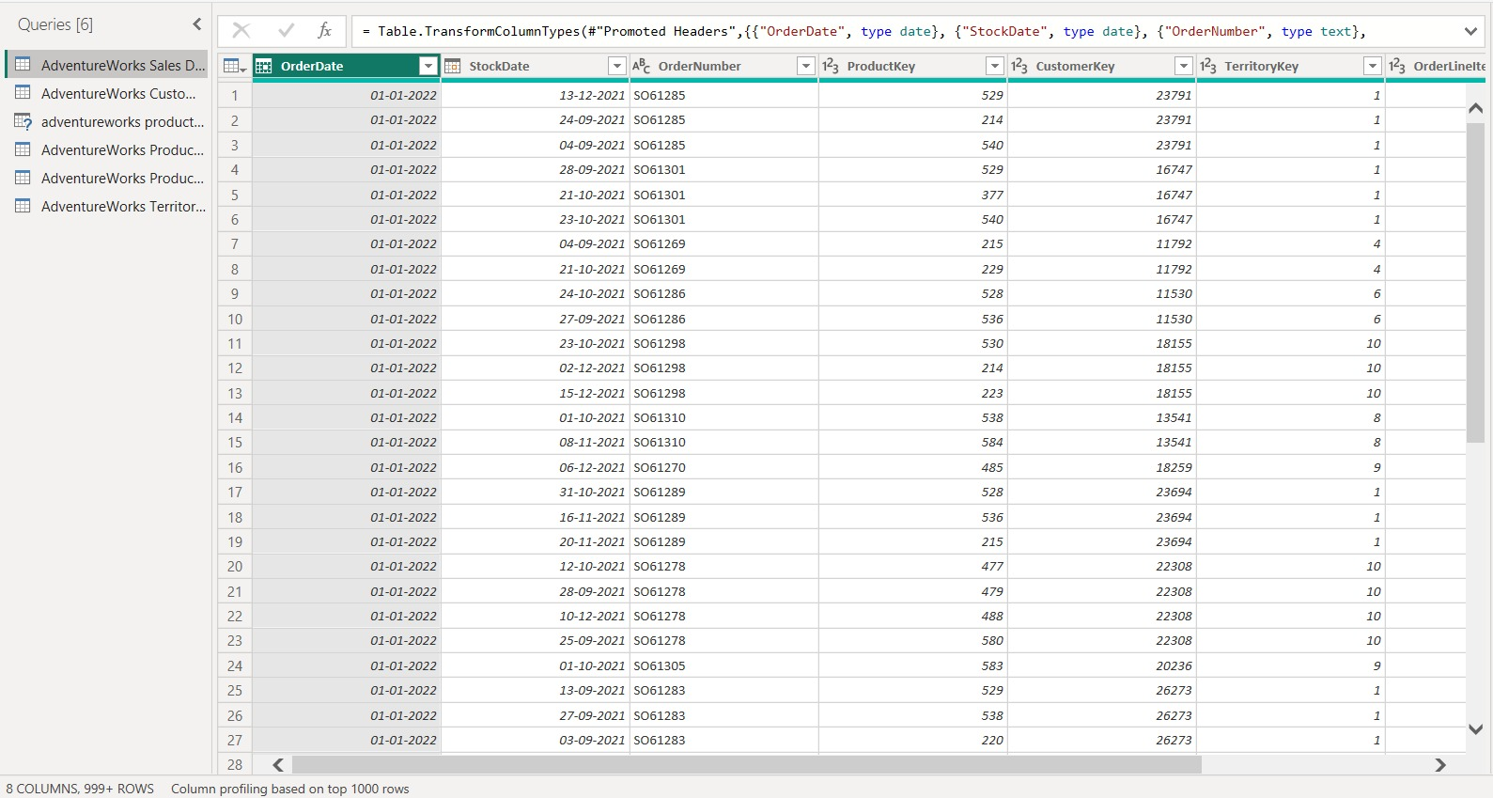
Fig 5: Cleaned Sales Data 2022 table
Step 5: Data Modeling
- Switched to Model view to connect all six tables into a single, unified data model.
- Connected the Sales Data 2022 table to the Customer Lookup table using CustomerKey.
- Connected the Sales Data 2022 table to the Product Lookup table using ProductKey.
- Connected the Sales Data 2022 table to the Territory Lookup table using TerritoryKey.
- Connected the Product Lookup table to the Product Subcategories Lookup table using ProductSubcategoryKey, and the Product Subcategories Lookup table to the Product Categories Lookup table using ProductCategoryKey, forming a snowflake-style hierarchy for product classification.
- Verified all relationships were one-to-many, with the Sales Data 2022 table acting as the central fact table.
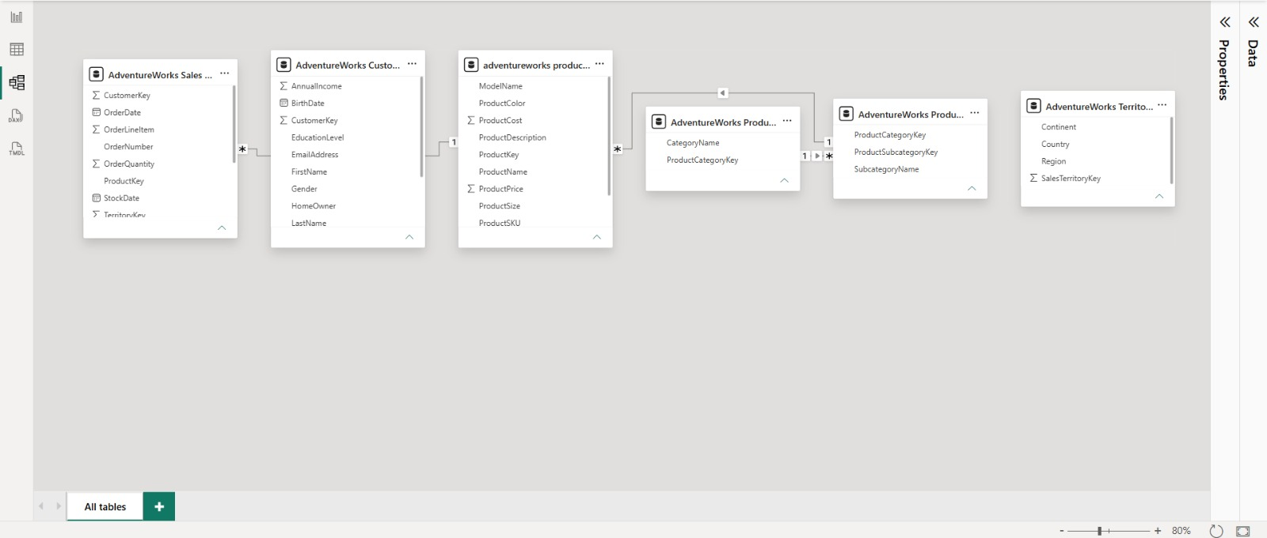
Fig 6: Data model showing relationships between all six tables
Step 6: DAX Measures
Created DAX measures on the Sales Data 2022 table to calculate key business KPIs:
- Total Sales
- Total Orders
- Total Customers
- Total Quantity Sold
- Average Order Value
Total Sales = SUM('AdventureWorks Sales Data 2022'[SalesAmount])
Total Orders = DISTINCTCOUNT('AdventureWorks Sales Data 2022'[OrderNumber])
Total Customers = DISTINCTCOUNT('AdventureWorks Customer Lookup'[CustomerKey])
Total Quantity Sold = SUM('AdventureWorks Sales Data 2022'[OrderQuantity])
Average Order Value = DIVIDE([Total Sales], [Total Orders])

Step 7: Dashboard Development
- Developed a "Retail Sales Performance Dashboard" using Power BI, spread across two report pages.
- Created KPI cards for Total Sales, Total Orders, and Total Customers.
- Built a bar chart showing Total Sales by Region.
- Built a column chart showing Total Sales by CategoryName.
- Built a bar chart showing Total Sales by ProductName.
- Built a line chart showing Total Sales by Year, Quarter, Month, and Day.
Step 8: Interactive Filters and Slicers
- Added a slicer for OrderDate.
- Added a slicer for Region.
- Added a slicer for CategoryName.
- These slicers allow users to dynamically filter the entire dashboard by time period, geography, and product category.
Step 9: Dashboard Formatting
- Added the title "Retail Sales Performance Dashboard" at the top of the report.
- Arranged KPI cards, charts, and slicers in a structured, easy-to-scan layout.
- Applied a light background color to the canvas for a clean, professional appearance.
- Formatted sales values with appropriate number formatting (M for millions, K for thousands).
- Adjusted chart titles, axis labels, and visual sizing for clarity and consistency.
Step 10: Analysis and Insights
- Overall sales performance across the full year (2022), totaling approximately 9.19M in sales.
- Order and customer volume, with roughly 12K total orders placed by around 11K unique customers.
- Regional sales performance across countries such as the United Kingdom, Australia, Canada, Germany, and France.
- Category-wise contribution to sales, with Bikes emerging as the dominant category over Accessories and Clothing.
- Top-performing individual products, led by the Mountain-200 series.
- Daily and monthly sales trends across the year, including a notable peak in early March.
Step 11: Final Dashboard
After completing data integration, transformation, modeling, DAX calculations, and visualization, the final Retail Sales Performance Dashboard was developed across two pages.
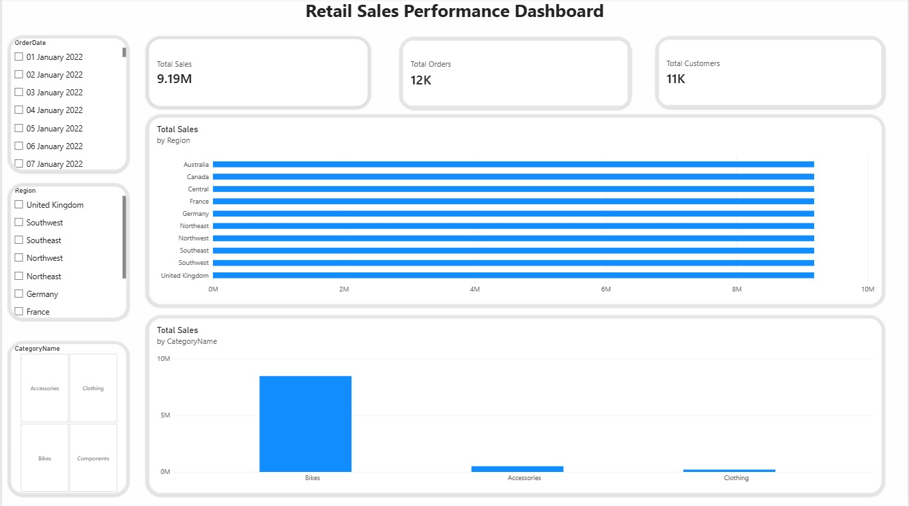
Fig 7: Dashboard – Overview (KPIs, Sales by Region, Sales by Category)
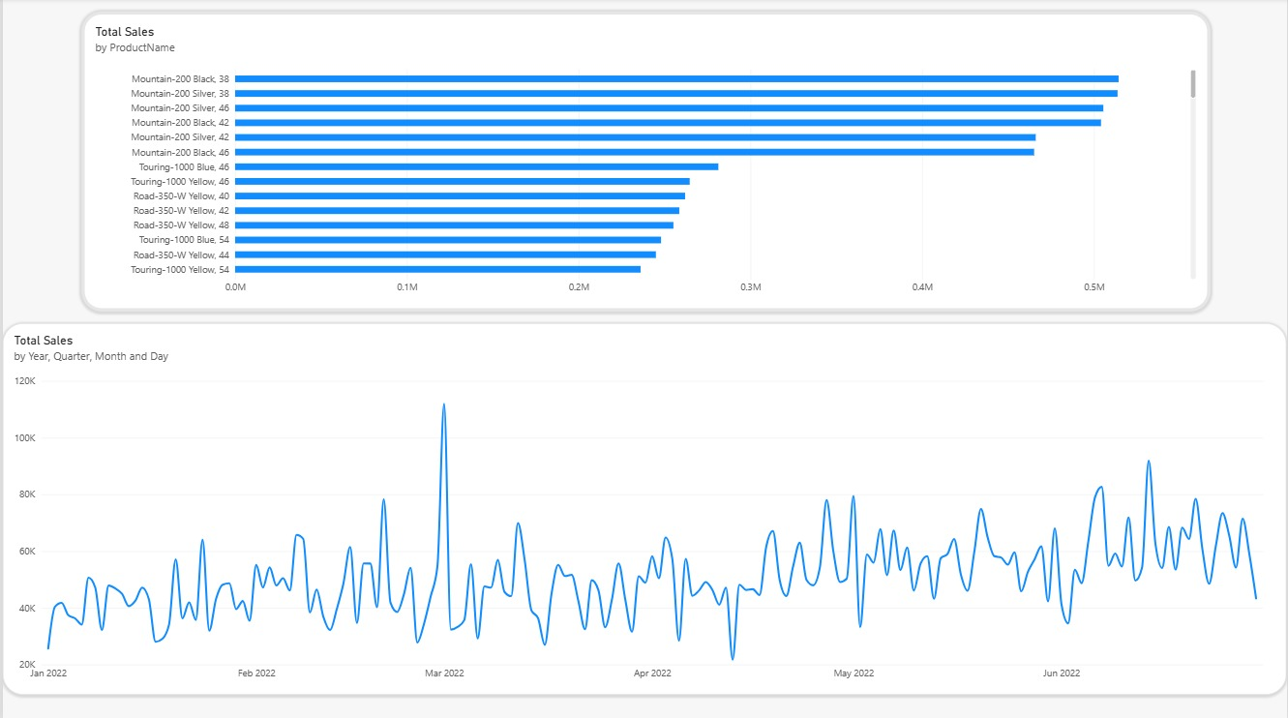
Fig 8: Dashboard – Product & Trend Analysis (Sales by Product, Monthly Trend)
Together, these pages provide a centralized and interactive view of business performance, enabling users to filter and analyze sales by date, region, category, and product — supporting faster, more informed business decisions.
Conclusion
This project successfully integrated data from six sources — Excel files, and a MySQL database for product data — into a single Power BI reporting model. The data was cleaned, transformed, and modeled into a snowflake schema connecting Sales, Customer, Product, Product Subcategory, Product Category, and Territory tables. DAX measures were developed to calculate key performance indicators such as Total Sales, Total Orders, Total Customers, and Average Order Value. The resulting Retail Sales Performance Dashboard presents this information through KPI cards, regional and category breakdowns, product-wise analysis, and monthly trend charts, supported by interactive slicers — providing a centralized view that supports data-driven business decisions.
Learning Outcomes
Through this project, I learned:
- Data Collection and Integration — how to work with data from multiple Excel sources and a MySQL database.
- MySQL Database Management — how to verify and manage a database and its tables using SQL commands.
- Power BI Data Import — how to connect Excel and MySQL sources to Power BI and load multiple related tables.
- Data Cleaning and Transformation — how to use Power Query to promote headers, fix data types, and remove invalid rows.
- Data Modeling — how to build a snowflake-schema data model connecting fact and dimension tables through common keys.
- DAX — how to create measures for KPIs such as Total Sales, Total Orders, and Average Order Value.
- Data Visualization — how to build KPI cards, bar charts, column charts, and trend lines.
- Interactive Dashboard Development — how to use slicers to let users filter by date, region, and category.
- Business Analysis — how to interpret sales trends, top products, and regional performance from a dashboard.
- Data-Driven Decision Making — practical understanding of how BI tools turn raw transactional data into actionable insights.

